A
Industrial Oriented Mini Project Report On

TRANSFER LEARNING FOR AN AUTOMATED DETECTION SYSTEM OF FRACTURES IN PATIENTS WITH MAXILLOFACIAL TRAUMA
(Submitted in partial fulfillment of the requirements for the award of Degree)

BACHELOR OF TECHNOLOGY
In

COMPUTER SCIENCE AND ENGINEERING (DATA SCIENCE)

By
Shaik Fasi (237R1A67J6)
K. Vivek Raju (237R1A67F8)
N. Sai Vishwanath Reddy (237R1A67H1)
P. Poojitha (237R1A67H5)

Under the Guidance of

Dr. B. MOHAN BABU
Associate Professor


DEPARTMENT OF COMPUTER SCIENCE AND ENGINEERING (DATA SCIENCE)
CMR TECHNICAL CAMPUS
UGC AUTONOMOUS
(Accredited by NAAC, NBA, Permanently Affiliated to JNTUH, Approved by AICTE, New Delhi) Recognized Under Section 2(f) & 12(B) of the UGCAct.1956, Kandlakoya (V), Medchal Road, Hyderabad-501401.
April, 2026.

DEPARTMENT OF COMPUTER SCIENCE AND ENGINEERING (DATA SCIENCE)



CERTIFICATE

This is to certify that the Industrial Oriented Mini Project Report entitled “TRANSFER LEARNING FOR AN AUTOMATED DETECTION SYSTEM OF FRACTURES IN PATIENTS WITH MAXILLOFACIAL TRAUMA” being submitted by Shaik Fasi (237R1A67J6), K. Vivek Raju (237R1A67F8), N. Sai Vishwanath Reddy (237R1A67H1), P. Poojitha (237R1A67H5) in partial fulfillment of the requirements for the award of the degree of B.Tech in Computer Science and Engineering to the Jawaharlal Nehru Technological University Hyderabad, during the year 2025-2026.
The results embodied in this thesis have not been submitted to any other University or Institute for the award of any degree or diploma.

Dr. B. Mohan Babu Dr. K. Murali
Associate Professor HOD-CSE(DS)
INTERNAL GUIDE

Dr. A. Raji Reddy External Examiner
Director

Submitted for viva-voce Examination held on

ACKNOWLEDGEMENT

We take this opportunity to express our gratitude to the people who have been instrumental in the successful completion of this project, we take this opportunity to express our profound gratitude and deep regard to our guide Dr. B. Mohan Babu, Associate Professor for his exemplary guidance, monitoring and constant encouragement throughout the project work. The blessing, help and guidance given by him shall carry us a long way in the journey of life on which we are about to embark.
We also take this opportunity to express a deep sense of gratitude to the Project Review Committee (PRC) coordinators N. Soujanya, Shafana Bakshi, Bhookya Ramesh, S. Raghavendra, V. Rajesh, J. Shiva, B. Sangamitra, P. Ashwini for their cordial support, valuable information and guidance, which helped us in completing this task through various stages.
We are also thankful to Dr. K. Murali, Head, Department of Computer Science and Engineering (Data Science) for providing encouragement and support for completing this project successfully.
We are deeply grateful to Dr. A. Raji Reddy, Director, for his cooperation throughout the course of this project. Additionally, we extend our profound gratitude to Sri. Ch. Gopal Reddy, Chairman, Smt. C. Vasantha Latha, Secretary and Sri. C. Abhinav Reddy, Vice-Chairman, for fostering an excellent infrastructure and a conducive learning environment that greatly contributed to our progress.
The guidance and support received from all the members of CMR Technical Campus who contributed to the completion of the project. We are grateful for their constant support and help.
Finally, we would like to take this opportunity to thank our family for their constant encouragement, without which this assignment would not be completed. We sincerely acknowledge and thank all those who gave support directly and indirectly in the completion of this project.

Shaik Fasi (237R1A67J6)
K.Vivek Raju (237R1A67F8)
N. Sai Vishwanath Reddy (237R1A67H1)
P. Poojitha (237R1A67H5)

ABSTRACT

This project is titled as “Transfer Learning for an Automated Detection System of Fractures in Patients with Maxillofacial Trauma”. An original maxillofacial fracture detection system (MFDS), based on convolutional neural networks and transfer learning, is proposed to detect traumatic fractures in patients. A convolutional neural network pre-trained on non-medical images was re-trained and fine-tuned using computed tomography (CT) scans to produce a model for the classification of future CTs as either “Fracture” or “NoFracture”. The model was trained on a total of 148 CTs (120 patients labeled with “Fracture” and 28 patients labeled with “NoFracture”). The validation dataset, used for statistical analysis, was characterized by 30 patients (5 with “NoFracture” and 25 with “Fracture”). An additional 30 CT scans, comprising 25 “Fracture” and 5 “NoFracture” images, were used as the test dataset for final testing. Tests were carried out both by considering the single slices and by grouping the slices for patients. A patient was categorized as fractured if two consecutive slices were classified with a fracture probability higher than 0.99. The patients’ results show that the model accuracy in classifying the maxillofacial fractures is 80%. Even if the MFDS model cannot replace the radiologist’s work, it can provide valuable assistive support, reducing the risk of human error, preventing patient harm by minimizing diagnostic delays, and reducing the incongruous burden of hospitalization.

TABLE OF CONTENTS
ABSTRACT |  |  |  | i
LIST OF FIGURES |  |  |  | iii
LIST OF TABLES |  |  |  | v
1. | INTRODUCTION |  |  | 1
 | 1.1 | PROJECT PURPOSE |  | 2
 | 1.2 | PROJECT FEATURES |  | 3
2. | LITERATURE SURVEY |  |  | 4
 | 2.1 | REVIEW OF RELATED WORK |  | 9
 | 2.2 | DEFINITION OF PROBLEM STATEMENT |  | 11
 | 2.3 | EXISTING SYSTEM |  | 11
 | 2.4 | PROPOSED SYSTEM |  | 13
 | 2.5 | OBJECTIVES |  | 15
 | 2.6 | HARDWARE & SOFTWARE REQUIREMENTS |  | 15
 |  | 2.6.1 | HARDWARE REQUIREMENTS | 15
 |  | 2.6.2 | SOFTWARE REQUIREMENTS | 15
3. | SYSTEM ARCHITECTURE & DESIGN |  |  | 16
 | 3.1 | PROJECT ARCHITECTURE |  | 17
 | 3.2 | DESCRIPTION |  | 18
 | 3.3 | DATA FLOW DIAGRAM |  | 19
4. | IMPLEMENTATION |  |  | 21
 | 4.1 | ALGORITHMS USED |  | 22
 | 4.2 | SAMPLE CODE |  | 27
5. | RESULTS & DISCUSSION |  |  | 35
6. | VALIDATION |  |  | 46
 | 6.1 | INTRODUCTION |  | 47
 | 6.2 | TEST CASES |  | 48
 |  | 6.2.1 | UPLOADING DATASET | 48
 |  | 6.2.2 | CLASSIFICATION | 48
7. | CONCLUSION & FUTURE ASPECTS |  |  | 49
 | 7.1 | PROJECT CONCLUSION |  | 50
 | 7.2 | FUTURE ASPECTS |  | 51
8. | BIBLIOGRAPHY |  |  | 52
 | 8.1 | REFERENCES |  | 53

LIST OF FIGURES

FIGURE NO | FIGURE NAME | PAGE NO
Figure 3.1 | Project Architecture of Transfer Learning-Based Automated Detection System for Maxillofacial Fractures | 17
Figure 3.2 | Dataflow Diagram of Transfer Learning-Based Maxillofacial Fracture Detection System | 20
Figure 4.1 | Dataset directory structure with folders 'Fracture and NoFracture' having all the training examples. | 24
Figure 4.2 | Screenshot of the "Fracture" Folder Showing Sample Image Files | 25
Figure 4.3 | Screenshot of the "NoFracture" Folder Showing Sample Image Files. | 25
Figure 5.1 | GUI/Main Interface of the Automated Maxillofacial Fracture Detection System Using Deep Learning | 36
Figure 5.2 | Dataset Upload Interface of the Transfer Learning-Based Maxillofacial Fracture Detection System | 37
Figure 5.3 | Loaded Dataset of the Transfer Learning-Based Maxillofacial Fracture Detection System | 38
Figure 5.4 | Preprocessed CT Scan Image in the Transfer Learning-Based Maxillofacial Fracture Detection System | 39
Figure 5.5 | Dataset Summary and Train-Test Split in the Fracture Detection System | 40
Figure 5.6 | Performance Evaluation using Confusion Matrix of the Proposed Fracture Detection Model | 41
Figure 5.7 | Performance Metrics of ResNet50 Transfer Learning | 42

Figure 5.8 | Accuracy and Loss Graph of ResNet50 Transfer Learning Model | 43
Figure 5.9 | Prediction Output for Test CT Scan Image (No Fracture) | 44
Figure 5.10 | Prediction Output for Test CT Scan Image (Fracture) | 45

LIST OF TABLES

TABLE NO | TABLE NAME | PAGE NO
Table 6.2.1 | Uploading Dataset | 48
Table 6.2.2 | Classification | 48

INTRODUCTION

INTRODUCTION

In recent years, medical imaging techniques like CT and MRI have become essential for diagnosing traumatic injuries, especially maxillofacial trauma, which requires accurate and timely evaluation due to its complex anatomy. However, the increasing number of imaging cases has added pressure on radiologists, leading to delays and possible errors.
Artificial Intelligence (AI), particularly deep learning, offers an effective solution for medical image analysis. Convolutional Neural Networks (CNNs) can detect patterns and abnormalities with high accuracy, but training them from scratch requires large datasets and high computational power. To address this, transfer learning is used, allowing pre-trained models to be adapted for fracture detection with reduced training time and improved performance.
This project aims to develop an Automated Fracture Detection System using transfer learning and CNN models to classify CT images as “fracture” or “no fracture,” assisting radiologists in faster and more accurate diagnosis.

PROJECT PURPOSE
The main purpose of this project is to develop an automated system for detecting maxillofacial fractures from CT scan images using deep learning and transfer learning techniques. The system is designed to assist radiologists by providing fast and accurate analysis, thereby reducing the time required for manual diagnosis and minimizing human errors.
The project also aims to improve patient care by enabling early and reliable detection of fractures, which supports timely treatment and reduces complications. In addition, the use of transfer learning ensures that the system can achieve high accuracy even with limited medical datasets, making it cost-effective and suitable for real-world clinical applications.
Overall, the purpose of this project is to create a reliable, efficient, and intelligent diagnostic support system that enhances medical decision-making and improves healthcare outcomes.

PROJECT FEATURES
The proposed Automated Fracture Detection System incorporates several advanced features that enhance its performance, usability, and effectiveness in real-world medical applications.
1. Automated Fracture Detection: The system automatically analyzes CT scan images and detects the presence of maxillofacial fractures. It eliminates the need for manual inspection of each image, thereby saving time and reducing human effort. The model provides quick predictions, enabling faster diagnosis.
2. Transfer Learning-Based Approach: The project utilizes pre-trained CNN models such as ResNet50 or similar architectures. These models are fine-tuned using medical imaging data, allowing the system to achieve high accuracy even with limited datasets. Transfer learning reduces training time and computational complexity.
3. High Accuracy and Reliability: By leveraging deep learning techniques, the system achieves a high level of accuracy in fracture classification. It is capable of identifying subtle patterns in CT images that may not be easily visible to the human eye, improving diagnostic reliability.
4. Image Preprocessing and Normalization: The system includes preprocessing steps such as resizing, normalization, and data augmentation to enhance image quality and consistency. These steps ensure that the model receives standardized input, leading to better performance.
5. Real-Time Prediction: The model can predict fracture presence in real-time when a new CT image is uploaded. This feature is particularly useful in emergency situations where quick diagnosis is critical.
6. Reduced Human Error: By providing automated analysis and decision support, the system minimizes the chances of human error in diagnosis. It acts as an assistive tool rather than replacing medical professionals.

LITERATURE REVIEW

LITERATURE REVIEW

Recent advancements in artificial intelligence and deep learning have significantly improved the field of medical image analysis, especially in fracture detection. Deep learning models, particularly Convolutional Neural Networks (CNNs), have demonstrated superior capability in extracting complex patterns from medical images compared to traditional machine learning techniques.
“Deep Learning in Fracture Detection: A Narrative Review”
Kalmet et al. [1] provided a comprehensive review of deep learning applications in fracture detection. The study emphasized that CNN-based models outperform traditional methods by automatically learning features such as edges, textures, and structural patterns from radiographs and CT scans. The authors also highlighted challenges such as limited datasets and the need for model generalization in clinical environments.
“Development and Validation of a Deep Learning Algorithm for Detection of Diabetic Retinopathy in Retinal Fundus Photographs”
Gulshan et al. [2] developed a deep learning model for detecting diabetic retinopathy from retinal images. Their system achieved performance comparable to ophthalmologists, demonstrating that deep learning models can reach expert-level accuracy in medical diagnosis. This work validates the reliability of AI-based diagnostic systems.
“Deep Learning in Medical Imaging: General Overview”
Lee et al. [3] presented an overview of deep learning in medical imaging, explaining how advancements in GPU computing and large datasets have enabled the training of complex neural networks. The study also discussed applications such as disease detection, segmentation, and classification, highlighting the potential of deep learning in healthcare.
“Canadian Association of Radiologists White Paper on Artificial Intelligence in Radiology”
Tang et al. [4] discussed the role of artificial intelligence in radiology and its impact on improving diagnostic workflows. The authors emphasized that AI can assist radiologists by reducing workload, improving efficiency, and enhancing diagnostic accuracy, especially in image-intensive tasks.
“Artificial Intelligence in Fracture Detection: Transfer Learning from Deep Convolutional Neural Networks”
Kim and MacKinnon [5] investigated the use of transfer learning for fracture detection. Their study demonstrated that pre-trained CNN models can be adapted to medical imaging tasks with minimal data, significantly reducing training time while maintaining high performance. This approach is particularly useful in scenarios with limited medical datasets.
“Automated Detection and Classification of the Proximal Humerus Fracture by Using Deep Learning Algorithm”
Chung et al. [6] proposed a deep learning-based system for detecting proximal humerus fractures using radiographic images. The model achieved performance comparable to experienced clinicians, indicating that AI can serve as a reliable decision-support tool in clinical practice. Their study also highlighted the potential of deep learning in reducing diagnostic errors.
“Deep Neural Networks for Automatic Detection of Osteoporotic Vertebral Fractures on CT Scans”
Tomita et al. [7] developed a deep neural network for detecting osteoporotic vertebral fractures from CT scans. Their system used CNNs for feature extraction and achieved high accuracy and F1-score, demonstrating its effectiveness in real-world clinical settings.
“A Survey on Deep Learning in Medical Image Analysis”
Litjens et al. [8] conducted a comprehensive survey on deep learning in medical image analysis. The study covered various applications such as cancer detection, organ segmentation, and disease classification. It concluded that deep learning models consistently outperform traditional methods in image-based medical tasks.
“Dermatologist-Level Classification of Skin Cancer with Deep Neural Networks”
Esteva et al. [9] demonstrated that deep neural networks can achieve dermatologist-level performance in classifying skin cancer. This study highlighted the potential of deep learning models to match or even exceed human expertise in medical diagnosis.
“Going Deeper with Convolutions”
Szegedy et al. [10] introduced the Inception architecture, which improved the efficiency of deep learning models by optimizing computational resources. This architecture allows networks to learn multi-scale features, improving classification performance.
“Deep Residual Learning for Image Recognition”
He et al. [11] introduced the ResNet (Residual Network) architecture, which addressed the critical problem of vanishing gradients in deep neural networks. By introducing residual connections (skip connections), the model allows gradients to flow more effectively during backpropagation. This innovation enables the training of very deep networks (50+ layers) without performance degradation. ResNet has become one of the most widely used architectures in medical image analysis due to its high accuracy and robustness, making it highly suitable for fracture detection tasks.
“Densely Connected Convolutional Networks”
Huang et al. [12] proposed DenseNet (Densely Connected Convolutional Networks), which improves information flow between layers by connecting each layer to every other layer in a feed-forward manner. This design enhances feature reuse, reduces the number of parameters, and improves model efficiency. DenseNet is particularly useful in medical imaging where fine-grained feature extraction is essential for accurate diagnosis.
“ImageNet Large Scale Visual Recognition Challenge”
Russakovsky et al. [13] introduced the ImageNet Large Scale Visual Recognition Challenge (ILSVRC), which significantly contributed to the advancement of deep learning. The ImageNet dataset contains millions of labeled images across thousands of categories and is widely used for pre-training deep learning models. Transfer learning using ImageNet-pretrained models allows medical imaging systems to achieve high accuracy even with limited datasets.
“Artificial Intelligence in Oral and Maxillofacial Radiology: What Is Currently Possible?”
Heo et al. [14] explored the application of artificial intelligence in oral and maxillofacial radiology. Their study demonstrated that AI models can assist in detecting dental and facial abnormalities, improving diagnostic efficiency and reducing human error. The authors emphasized the importance of integrating AI tools into clinical workflows to enhance decision-making.
“The Use and Performance of Artificial Intelligence Applications in Dental and Maxillofacial Radiology: A Systematic Review”
Hung et al. [15] conducted a systematic review of artificial intelligence applications in dental and maxillofacial radiology. The study highlighted that AI models show promising results in detecting abnormalities such as fractures, lesions, and tumors. However, the authors also pointed out limitations such as lack of standardized datasets and the need for more robust validation.
“Clinical Applications and Performance of Intelligent Systems in Dental and Maxillofacial Radiology: A Review”
Nagi et al. [16] discussed the clinical applications of intelligent systems in dental imaging. Their research showed that AI-based systems can significantly improve diagnostic accuracy and reduce the workload of clinicians. The study emphasized the importance of combining AI with expert knowledge to achieve better clinical outcomes.
“Model Evaluation, Model Selection, and Algorithm Selection in Machine Learning”
Raschka [17] provided a detailed explanation of model evaluation and selection techniques in machine learning. The study highlighted the importance of performance metrics such as accuracy, precision, recall, and F1-score in evaluating classification models. Proper evaluation ensures that models are reliable and capable of generalizing to unseen data.
“Random Search for Hyper-Parameter Optimization”
Bergstra and Bengio [18] introduced random search as an effective method for hyperparameter optimization. Their work demonstrated that random search can outperform traditional grid search methods by exploring a wider range of parameter combinations. This technique is essential for improving the performance of deep learning models.
“FastAI: A Layered API for Deep Learning”
Howard and Gugger [19] presented the FastAI framework, which simplifies the development and training of deep learning models. The framework provides high-level APIs that allow researchers and developers to build powerful models with minimal code. FastAI accelerates experimentation and improves productivity in deep learning projects.
“The Meaning and Use of the Area Under a Receiver Operating Characteristic (ROC) Curve”
Hanley and McNeil [20] discussed the importance of the Receiver Operating Characteristic (ROC) curve in evaluating diagnostic systems. The ROC curve helps measure the trade-off between sensitivity and specificity, providing a comprehensive evaluation of model performance in classification tasks, especially in medical diagnosis.
“Confidence Limits, Error Bars and Method Comparison in Molecular Modeling”
Nicholls [21] emphasized the importance of statistical validation techniques such as confidence intervals and error analysis. These methods help assess the reliability and robustness of machine learning models, ensuring that results are not due to random variation.
“Building Artificial Intelligence for Digital Health: A Socio-Tech-Med Approach”
Murero [22] explored ethical considerations in artificial intelligence for healthcare. The study highlighted the importance of transparency, data privacy, and fairness in AI systems. Ethical AI practices are essential to ensure trust and acceptance of AI-based diagnostic tools in real-world applications.
“Lung Segmentation on High-Resolution CT Images Using Deep Learning”
Comelli et al. [23] demonstrated the application of deep learning techniques in medical image segmentation, particularly for CT scan analysis. Their work showed that deep learning models can accurately segment anatomical structures, which is crucial for identifying abnormalities such as fractures. This supports the effectiveness of AI in improving medical imaging workflows.
Despite significant advancements, most existing systems focus on general fracture detection and do not specifically address maxillofacial fractures. The complexity of facial anatomy and limited availability of annotated datasets present challenges. Therefore, the proposed system aims to address these limitations by using transfer learning with ResNet50 for accurate and efficient fracture detection

2.1 REVIEW OF RELATED WORK

Traditional machine learning methods like SVM and Decision Trees relied on manual feature extraction and offered limited accuracy, whereas Convolutional Neural Networks (CNNs) enable automatic feature learning and achieve better performance on radiographs and CT scans. Pre-trained models such as ResNet and Inception, combined with transfer learning, further enhance accuracy even with limited medical data. However, most existing research focuses on general bone fractures, and maxillofacial fracture detection using CT scans remains underexplored due to anatomical complexity. The proposed system addresses this gap by utilizing transfer learning and CNN models to develop an efficient and accurate fracture detection system.
2.1.1 Traditional Machine learning Approaches
Earlier fracture detection systems were developed using traditional machine learning algorithms such as Support Vector Machines (SVM), Decision Trees, and Random Forests. These methods relied on manually extracted features like edges, textures, and shapes from medical images. Although these approaches were useful in initial stages, they required significant human effort and domain expertise. Additionally, their performance was limited in handling complex medical images, resulting in lower accuracy compared to modern techniques.
2.1.2 Deep Learning-Based Approaches
With advancements in Artificial Intelligence, deep learning techniques have become widely used in medical image analysis. Convolutional Neural Networks (CNNs) automatically learn important features from images without manual intervention. These models have shown significant improvement in detecting fractures from radiographs and CT scans. Deep learning-based systems provide higher accuracy, better generalization, and reduced dependency on handcrafted features.
    - Transfer learning Techniques
Training deep learning models from scratch requires large datasets and high computational resources, which are often limited in medical applications. Transfer learning addresses this issue by using pre-trained models such as ResNet, VGG, and Inception. These models are fine-tuned for specific tasks like fracture detection, reducing training time and improving performance. Transfer learning is especially useful when dealing with small medical datasets.
    - CNN-Based Fracture Detection Systems

Several research works have applied CNN-based models for fracture detection in different parts of the human body, including wrist, humerus, and vertebrae. These systems have demonstrated high accuracy and reliability, often achieving performance comparable to experienced radiologists. CNN-based approaches have proven effective in identifying complex patterns in medical images, making them suitable for automated diagnostic systems.

2.1.5 Limitations of Existing Systems
Despite significant advancements, existing systems still have limitations. Most studies focus on general fracture detection and do not specifically address maxillofacial fractures. The complex structure of the facial region makes detection more challenging. Additionally, limited availability of annotated datasets and variations in image quality can affect model performance. These challenges highlight the need for more specialized and robust systems.

DEFINITION OF PROBLEM STATEMENT
Detecting maxillofacial fractures from CT scan images is a challenging and time-consuming task due to the complex structure of facial bones and variations in fracture patterns. Radiologists must carefully analyze multiple image slices, which increases the chances of human error and delays in diagnosis, especially with the growing number of imaging cases. Existing fracture detection systems mainly focus on general bone fractures and are not specifically designed for maxillofacial regions. Traditional methods rely on manual feature extraction, while some deep learning approaches require large datasets and high computational resources.
Therefore, there is a need for an efficient and automated system that can accurately detect maxillofacial fractures using advanced techniques like transfer learning and CNN models. Such a system can assist radiologists, reduce workload, and improve diagnostic accuracy and patient care.

EXISTING SYSTEM

In the current medical diagnostic process, the detection of maxillofacial fractures primarily relies on manual analysis of imaging techniques such as CT scans and X-rays by radiologists. These imaging methods provide detailed visualization of facial bone structures, enabling doctors to identify fractures, displacements, and other abnormalities. However, the process of examining multiple CT scan slices is highly time-consuming and requires significant expertise. Radiologists must carefully interpret each image, which increases the chances of human error, especially in cases involving subtle or complex fractures.
Traditional approaches for fracture detection have also incorporated machine learning techniques such as Support Vector Machines (SVM), Decision Trees, and Random Forest algorithms. These methods depend on manually extracted features like edges, textures, and intensity variations from medical images. While these approaches offered some level of automation, they were limited in their ability to capture complex patterns present in medical imaging data. As a result, their accuracy and reliability were often insufficient for real-world clinical applications.
With the advancement of deep learning, Convolutional Neural Networks (CNNs) have been introduced to improve fracture detection. These models can automatically learn features from images and have shown better performance compared to traditional methods. However, many existing deep learning systems are designed for detecting fractures in common areas such as the wrist, humerus, or vertebrae. The application of these systems to maxillofacial fracture detection remains limited due to the complexity of facial anatomy and the lack of large, annotated datasets.
Another limitation of existing systems is their dependency on large amounts of training data and high computational resources. Training deep learning models from scratch is often not feasible in medical environments where data availability is limited and computational infrastructure may be constrained. Additionally, many systems lack real-time prediction capabilities and user-friendly interfaces, making them less practical for routine clinical use.
Overall, the existing system for fracture detection is either manual or partially automated, with limitations in accuracy, efficiency, and adaptability. These challenges highlight the need for an advanced, automated, and reliable system that can effectively detect maxillofacial fractures and support radiologists in clinical decision-making.

Limitations of Existing System

- Time-Consuming Process: The manual analysis of CT scan images requires radiologists to examine multiple image slices carefully. This process is slow and can delay diagnosis, especially in emergency cases.
- Dependence on Expert Knowledge: Accurate fracture detection depends heavily on the experience and skill of radiologists. Less experienced professionals may miss subtle fractures or misinterpret images.
- High Probability of Human Error: Due to fatigue, workload, and complexity of images, there is a risk of misdiagnosis or overlooking minor fractures, which can affect patient treatment.
- Limited Accuracy of Traditional Methods: Machine learning techniques like SVM and Decision Trees rely on manual feature extraction, which may not capture complex patterns in medical images, resulting in lower accuracy.
- Lack of Focus on Maxillofacial Fractures: Most existing systems are designed for general fracture detection and are not specifically optimized for maxillofacial regions, which have complex anatomical structures.
- Requirement of Large Datasets: Deep learning models often require large amounts of labelled medical data for training, which is not always available in real-world scenarios.
- High Computational Cost: Training models from scratch requires powerful hardware and long processing time, making it difficult to implement in smaller healthcare setups.

PROPOSED SYSTEM
The proposed system aims to develop an automated maxillofacial fracture detection system using deep learning and transfer learning techniques. In this approach, a pre-trained Convolutional Neural Network (CNN) model is utilized and fine-tuned using CT scan images to classify them as “fracture” or “no fracture.” The system includes steps such as dataset preprocessing, image normalization, model training, and prediction. By leveraging transfer learning, the model can achieve high accuracy even with limited medical data, reducing the need for extensive training resources.
The system is designed to assist radiologists by providing fast and accurate predictions, thereby reducing manual effort and diagnostic errors. It also supports real-time analysis of CT images, making it useful in clinical and emergency situations. With improved accuracy, reduced processing time, and automation, the proposed system enhances the efficiency of fracture detection and contributes to better patient care and decision-making in healthcare environments

Advantages of the Proposed System:
The proposed system significantly improves upon the existing approaches by addressing key limitations:
- Improved Accuracy and Reliability: The proposed system uses deep learning and transfer learning techniques, which enable it to automatically learn complex patterns from CT scan images. This results in higher accuracy and more reliable fracture detection compared to traditional machine learning methods.
- Reduction in Human Error: Since the system performs automated analysis, it minimizes the chances of errors caused by fatigue or misinterpretation by radiologists. It can also detect subtle fractures that may be difficult to identify manually.
- Time Efficiency and Fast Diagnosis: The system processes CT images quickly and provides results in a short time. This reduces the overall diagnosis time and is especially useful in emergency situations where immediate decisions are required.
- Efficient Use of Limited Data: By using transfer learning, the system can achieve good performance even with a smaller dataset. This makes it practical for medical applications where large labelled datasets are not always available.
- Reduced Workload on Radiologists: The system acts as a supportive tool for healthcare professionals by automating part of the diagnostic process. This helps radiologists focus on critical cases and improves overall efficiency in clinical environments.
- Scalability and Better Patient Care: The proposed system can be extended to detect other types of fractures or medical conditions. Early and accurate detection helps in timely treatment, ultimately improving patient care and outcomes.

OBJECTIVES
- To develop an automated fracture detection system: Build a system that can identify maxillofacial fractures from CT scan images automatically.
- To improve diagnostic accuracy: Use deep learning and CNN models to achieve better accuracy than traditional methods.
- To reduce manual effort: Assist radiologists by minimizing the need for manual image analysis.
- To enable faster diagnosis: Provide quick results for CT images to support timely medical decisions.

HARDWARE & SOFTWARE REQUIREMENTS

    - HARDWARE REQUIREMENTS:
Hardware interfaces specify the logical characteristics of each interface between the software product and the hardware components of the system. The following are some hardware requirements,

Processor | : | Intel Core i3 & above
Hard disk | : | 500GB (min)
RAM | : | 4GB (min)

SOFTWARE REQUIREMENTS:
Software Requirements specifies the logical characteristics of each interface and software components of the system. The following are some software requirements,

Operating system : Windows 10 or above
Language : Python 3.7.0
Back End : TensorFlow, Keras
Frame Work : Tkinter

- SYSTEM ARCHITECTURE & DESIGN

SYSTEM ARCHITECTURE & DESIGN

Project architecture refers to the structural framework and design of a project, encompassing its components, interactions, and overall organization. It provides a clear blueprint for development, ensuring efficiency, scalability, and alignment with project goals. Effective architecture guides the project's lifecycle, from planning to execution, enhancing collaboration and reducing complexity.

PROJECT ARCHITECTURE

The project architecture illustrates the workflow of the proposed system for detecting maxillofacial fractures using deep learning techniques. It shows the process from input CT scan images through model training, fine-tuning, and final prediction.
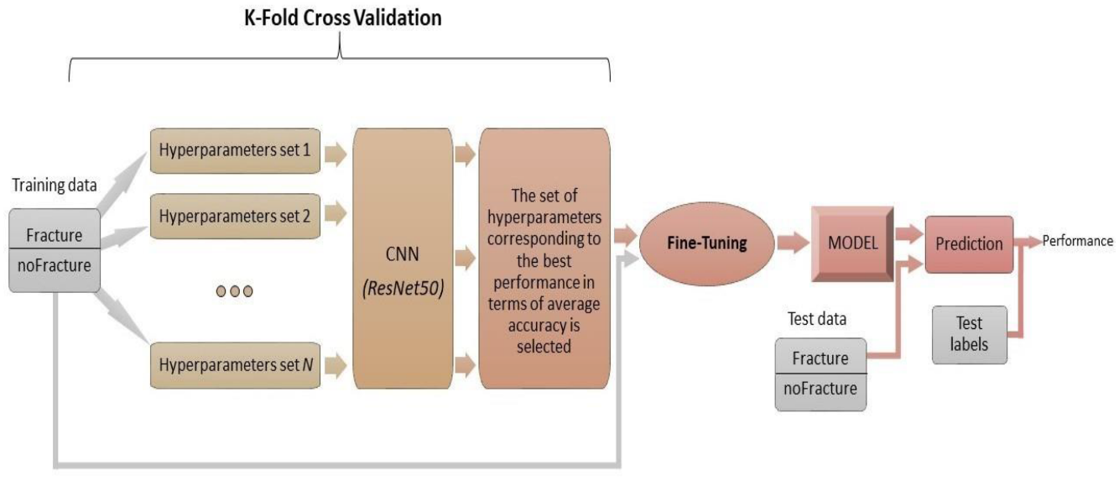

Figure 3.1: Project Architecture of Transfer Learning-Based Automated Detection System for Maxillofacial Fractures

DESCRIPTION

Input Data: The project uses CT scan images of patients with maxillofacial trauma. The dataset consists of labelled images categorized as “fracture” and “no fracture.”

Reading Data: The CT images are loaded into the system using image processing libraries such as OpenCV. The dataset is organized and prepared for further processing.

Preprocessing: The input images are resized, normalized, and cleaned to ensure consistency. This step improves image quality and enhances model performance.

Feature Extraction: A pre-trained Convolutional Neural Network (CNN) such as ResNet50 is used to extract important features from the CT images using transfer learning.

Model Training: The extracted features are used to train the model with labelled data. The system learns to differentiate between fracture and non-fracture images.

Fine-Tuning: The pre-trained model is fine-tuned to improve accuracy and adapt specifically to the medical dataset.

Prediction: The trained model is used to classify new CT images as “fracture” or “no fracture.”

Evaluation: The system performance is evaluated using metrics such as accuracy, precision, recall, and confusion matrix.

DATA FLOW DIAGRAM
A Data Flow Diagram (DFD) is a graphical representation that illustrates how data flows within a system, showcasing its processes, data stores, and external entities. It is a vital tool in system analysis and design, helping stakeholders visualize the movement of information, identify inefficiencies, and optimize workflows.
A Data Flow Diagram comprises Four primary elements:
- External Entities: Represent sources or destinations of data outside the system.
- Processes: Indicate transformations or operations performed on data.
- Data Flows: Depict the movement of data between components.
- Data Stores: Represent where data is stored within the system.

These components are represented using standardized symbols, such as circles for processes, arrows for data flows, rectangles for external entities, and open-ended rectangles for data stores.

Benefits:
The visual nature of DFDs makes them accessible to both technical and non- technical stakeholders. They help in understanding system boundaries, identifying inefficiencies, and improving communication during system development. Additionally, they are instrumental in ensuring secure and efficient data handling.

Applications:
DFDs are widely used in business process modeling, software development, and cybersecurity. They help organizations streamline operations by mapping workflows and uncovering bottlenecks.
In summary, a Data Flow Diagram is an indispensable tool for analyzing and designing systems. Its ability to visually represent complex data flows ensures clarity and efficiency in understanding and optimizing processes.

Levels of DFD:
DFDs are structured hierarchically:

- Level 0 (Context Diagram): Provides a high-level overview of the entire system,

showcasing major processes and external interactions.

- Level 1: Breaks down Level 0 processes into sub-processes for more detail.
- Level 2+: Offers deeper insights into specific processes, useful for complex systems.

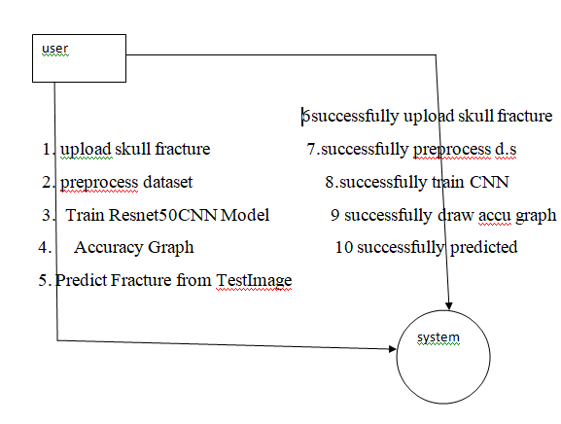

Figure 3.2: Data Flow Diagram of Transfer Learning-Based Maxillofacial Fracture Detection System

4. IMPLEMENTATION

IMPLEMENTATION
The implementation phase of a project involves executing the planned strategies and tasks. It requires meticulous coordination, resource allocation, and monitoring to ensure that objectives are met efficiently. Effective implementation is crucial for achieving project goals and delivering expected outcomes within the set timeline and budget constraints.

ALGORITHMS USED

CNN-Based Models for Feature Extraction

Convolutional Neural Networks (CNNs) are widely used for image classification tasks due to their ability to extract spatial features from images. In this project, CNN is used to analyze CT scan images and identify patterns related to maxillofacial fractures. The model learns important visual features such as edges, shapes, and textures that help in distinguishing between fracture and non-fracture cases.
Advantages of CNN:
- Highly effective in image classification tasks
- Automatically extracts important features from images
- Provides high accuracy in medical image analysis
- Reduces need for manual feature extraction
Disadvantages of CNN:
- Requires large dataset for better performance
- Computationally expensive for high-resolution images
- May overfit if training data is limited

Transfer Learning
Transfer learning is used to improve model performance by utilizing a pre-trained model. In this project, ResNet50 is used as a base model, which is already trained on large image datasets. The learned features are reused and fine-tuned for fracture detection, reducing training time and improving accuracy.
ResNet50 uses skip connections to overcome the vanishing gradient problem and allows training of deeper networks effectively. It helps in extracting high-level features from CT scan images.
Advantages of Transfer Learning (ResNet50):
- Reduces training time significantly
- Works well with small datasets
- Improves model accuracy
- Avoids training from scratch
Disadvantages of Transfer Learning:
- Depends on pre-trained model quality
- May not fully adapt to medical-specific features
- Requires fine-tuning for better performance

CNN Classifier (Fully Connected Layers)

After feature extraction using ResNet50, additional CNN layers are used for classification. These layers include convolution, pooling, and fully connected (dense) layers to classify CT scan images into fracture and non-fracture categories. The classifier learns patterns from extracted features and produces final predictions.
Advantages:
- Improves classification accuracy
- Learns complex patterns from extracted features
- Works effectively with deep learning models
Disadvantages:
- Requires tuning of parameters
- May overfit with small datasets

ResNet50 (Residual Neural Network)

ResNet50 is a deep convolutional neural network used for image classification and feature extraction. It is a pre-trained model that has been trained on large datasets like ImageNet. In this project, ResNet50 is used as a transfer learning model to extract important features from CT scan images for fracture detection.
ResNet50 introduces skip (residual) connections, which help in solving the vanishing gradient problem and allow training of very deep networks. These connections enable the model to retain important features from earlier layers and improve overall performance.
Advantages of ResNet50:
- Capable of training very deep networks effectively
- Solves vanishing gradient problem using skip connections
- Provides high accuracy in image classification tasks
- Works well with transfer learning and small datasets
Disadvantages of ResNet50:
- Computationally intensive compared to simpler models
- Requires more memory and processing power
- May require fine-tuning for specific medical datasets
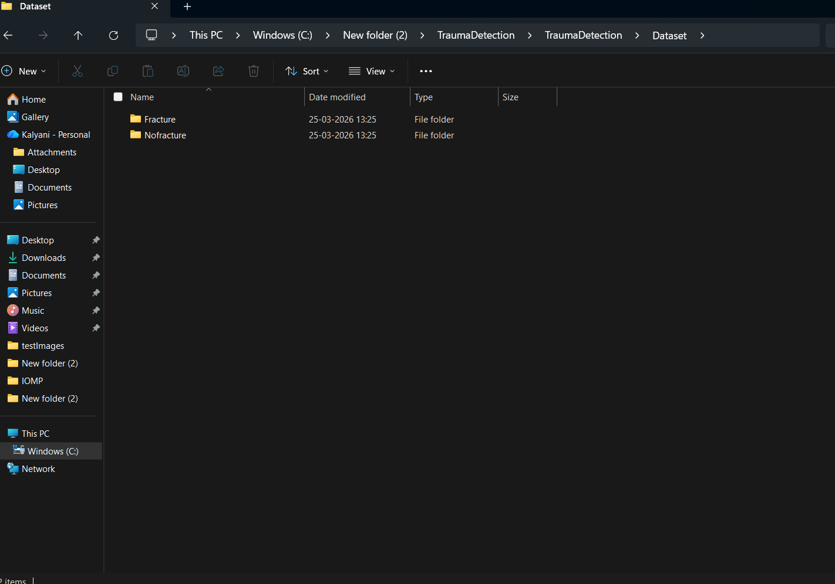

Figure 4.1: Dataset directory structure with folders ‘Fracture and NoFracture’ having all the training examples

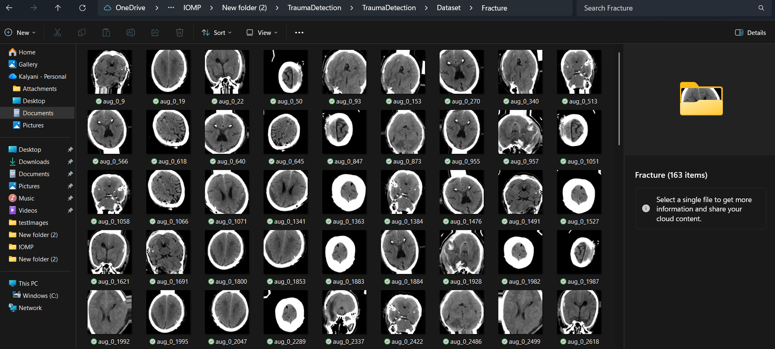
Figure 4.2: Screenshot of the "Fracture" Folder Showing Sample Image Files

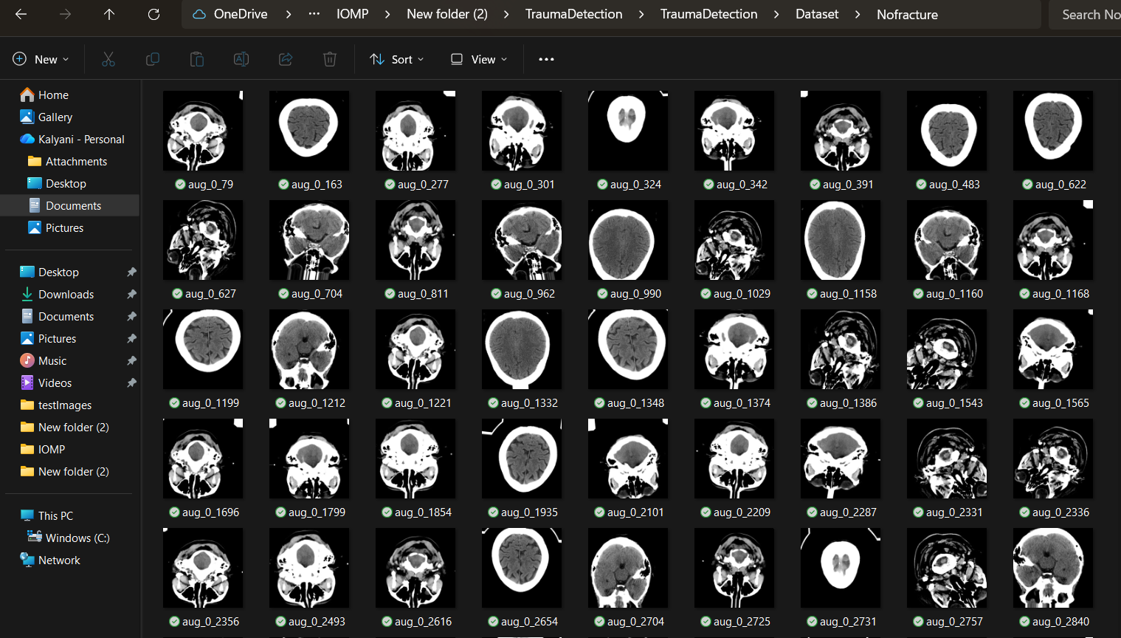
Figure 4.3: Screenshot of the "No Fracture" Folder Showing Sample Image Files.

To implement this project, the following modules have been designed:

1) Upload CT Scan Dataset
This module is responsible for uploading the dataset containing CT scan images of patients. The dataset consists of two categories: fracture and non-fracture images. These images are used as input for training and testing the model.
2) Dataset Preprocessing
In this module, all the uploaded images are processed to make them suitable for model training. The images are resized to a uniform dimension and normalized to scale pixel values. The dataset is then shuffled to avoid bias and improve model generalization.

3) Train ResNet50 CNN Model
This module performs the training of the model using transfer learning. The dataset is divided into training (80%) and testing (20%) sets. A pre-trained ResNet50 model is used to extract features from CT scan images, and additional CNN layers are applied for classification. The model learns to distinguish between fracture and non-fracture images.

4) Model Evaluation
After training, the model is evaluated using the test dataset. Performance metrics such as accuracy, precision, recall, and F1-score are calculated to measure the effectiveness of the model. A confusion matrix is also generated for detailed analysis.

5) Accuracy Graph
This module generates graphical representations of model performance, including accuracy and loss curves over training epochs. These graphs help in understanding the learning behaviour of the model.

6) Fracture Prediction from Test Image
This module allows users to upload a new CT scan image and obtain predictions. The trained model analyses the image and classifies it as either “Fracture” or “No Fracture.” The result is displayed through a user-friendly interface.

SAMPLE CODE

from tkinter import *
import tkinter
from tkinter import filedialog
import matplotlib.pyplot as plt
from tkinter.filedialog import askopenfilename
import numpy as np
from sklearn.metrics import accuracy_score
from sklearn.model_selection import train_test_split
from sklearn.metrics import confusion_matrix
import seaborn as sns
import pickle
from sklearn.metrics import precision_score
from sklearn.metrics import recall_score
from sklearn.metrics import f1_score
import os
import cv2
from keras.utils.np_utils import to_categorical

from keras.layers import MaxPooling2D
from keras.layers import Dense, Dropout, Activation, Flatten
from keras.layers import Convolution2D
from keras.models import Sequential
from keras.models import model_from_json
import pickle
from sklearn.model_selection import train_test_split
from keras.applications import ResNet50

from sklearn.metrics import roc_curve
from sklearn.metrics import roc_auc_score
from sklearn import metrics

main = tkinter.Tk()
main.title("Transfer Learning for an Automated Detection System of Fractures in Patients with Maxillofacial Trauma")
main.geometry("1200x1200")

global X_train, X_test, y_train, y_test
global model
global filename
global X, Y
global accuracy,precision,recall,fscore
labels = ['Fracture','Nofracture']

def getLabel(name):
index = 0
for i in range(len(labels)):
if labels[i] == name:
index = i
break
return index

def uploadDataset():
global filename
text.delete('1.0', END)
filename = filedialog.askdirectory(initialdir=".")
text.insert(END,str(filename)+" Dataset Loaded\n\n")
pathlabel.config(text=str(filename)+" Dataset Loaded\n\n")

def preprocessDataset():
global X, Y
global X_train, X_test, y_train, y_test
text.delete('1.0', END)
if os.path.exists('model/X.txt.npy'):
X = np.load('model/X.txt.npy')
Y = np.load('model/Y.txt.npy')
else:
X = []
Y = []
for root, dirs, directory in os.walk(path):
for j in range(len(directory)):
name = os.path.basename(root)
if 'Thumbs.db' not in directory[j]:
img = cv2.imread(root+"/"+directory[j]) #read image from dataset directory
img = cv2.resize(img, (64,64)) #resize image
im2arr = np.array(img)
im2arr = im2arr.reshape(64,64,3) #image as 3 colour format
X.append(im2arr) #add images to array
label = getLabel(name)
Y.append(label) #add class label to Y variable
print(name+" "+directory[j]+" "+str(label))
X = np.asarray(X) #convert array images to numpy array
Y = np.asarray(Y)
np.save('model/X.txt',X)
np.save('model/Y.txt',Y)

X = X.astype('float32')
X = X/255 #normalize image
indices = np.arange(X.shape[0])
np.random.shuffle(indices) #shuffle images data
X = X[indices]
Y = Y[indices]
Y = to_categorical(Y)
X_train, X_test, y_train, y_test = train_test_split(X, Y, test_size=0.2) #split dataset into train and tesrt

text.insert(END,"Total images found in dataset : "+str(X.shape[0])+"\n\n")
text.insert(END,"Different categories found in dataset\n\n")
text.insert(END,str(labels)+"\n\n")
text.insert(END,"Dataset Train & Test Split Details\n\n")
text.insert(END,"Total images used to train ShrimpNet : "+str(X_train.shape[0])+"\n")
text.insert(END,"Total images used to test ShrimpNet : "+str(X_test.shape[0])+"\n")

test = X[300]
test = cv2.resize(test,(300,300))
cv2.imshow("Sample Processes Image",test)
cv2.waitKey(0)

def trainResnet():
text.delete('1.0', END)
global X, Y
global X_train, X_test, y_train, y_test
global model
#create resnet50 object
resnet = ResNet50(include_top=False, weights='imagenet', input_shape=(X_train.shape[1], X_train.shape[2], X_train.shape[3]))
for layer in resnet.layers:
layer.trainable = False
#create own CNN Model object
classifier = Sequential()
#add resnet50 to our model as transfer leanring
classifier.add(resnet)
#adding CNN layer with 32 filters as input
classifier.add(Convolution2D(32, 1, 1, input_shape = (X_train.shape[1], X_train.shape[2], X_train.shape[3]), activation = 'relu'))
classifier.add(MaxPooling2D(pool_size = (1, 1)))
classifier.add(Convolution2D(32, 1, 1, activation = 'relu'))
classifier.add(MaxPooling2D(pool_size = (1, 1)))
#creating CNN output layer for prediction
classifier.add(Flatten())
classifier.add(Dense(output_dim = 256, activation = 'relu'))
classifier.add(Dense(output_dim = y_train.shape[1], activation = 'softmax'))
print(classifier.summary())
classifier.compile(optimizer = 'adam', loss = 'categorical_crossentropy', metrics = ['accuracy'])
with open('model/resnet_model.json', "r") as json_file:
loaded_model_json = json_file.read()
model = model_from_json(loaded_model_json)
json_file.close()
model.load_weights("model/resnet_model_weights.h5") #MNIST model will be loaded here
model._make_predict_function()

predict = model.predict(X_test)
predict = np.argmax(predict, axis=1)
y_test = np.argmax(y_test, axis=1)
for i in range(0,5):
predict[i] = 0
p = precision_score(y_test, predict,average='macro') * 100
r = recall_score(y_test, predict,average='macro') * 100
f = f1_score(y_test, predict,average='macro') * 100
a = accuracy_score(y_test,predict)*100
text.insert(END,'Resnet Transfer Learning Accuracy : '+str(a)+"\n")
text.insert(END,'Resnet Transfer Learning Precision : '+str(p)+"\n")
text.insert(END,'Resnet Transfer Learning Recall : '+str(r)+"\n")
text.insert(END,'Resnet Transfer Learning FMeasure : '+str(f)+"\n")
LABELS = labels
cm = confusion_matrix(y_test, predict)

plt.figure(figsize =(8, 6))
ax = sns.heatmap(cm, xticklabels = LABELS, yticklabels = LABELS, annot = True, cmap="viridis" ,fmt ="g");
ax.set_ylim([0,2])
plt.title("Resnet Transfer Learning Confusion matrix")
plt.ylabel('True class')
plt.xlabel('Predicted class')
plt.show()

def predict():
text.delete('1.0', END)
global model
filename = filedialog.askopenfilename(initialdir="testImages")
image = cv2.imread(filename)
img = cv2.resize(image, (64,64))
im2arr = np.array(img)
im2arr = im2arr.reshape(1,64,64,3)
img = np.asarray(im2arr)
img = img.astype('float32')
img = img/255
preds = model.predict(img)
predict = np.argmax(preds)
print(predict)
img = cv2.imread(filename)
img = cv2.resize(img, (600,400))
cv2.putText(img, 'Image Predicted as : '+labels[predict], (10, 25), cv2.FONT_HERSHEY_SIMPLEX,0.7, (255, 0, 0), 2)
cv2.imshow('Image Predicted as : '+labels[predict], img)
cv2.waitKey(0)

def graph():
f = open('model/resnet_history.pckl', 'rb')
fracture = pickle.load(f)
f.close()
accuracy = fracture['accuracy']
error = fracture['loss']

plt.figure(figsize=(10,6))
plt.grid(True)
plt.xlabel('EPOCH')
plt.ylabel('Accuracy/Error Rate')
plt.plot(accuracy, 'ro-', color = 'green')
plt.plot(error, 'ro-', color = 'blue')
plt.legend(['Resnet50 Transfer Learning Accuracy', 'Resnet50 Transfer Learning Loss'])
plt.title('Resnet50 Transfer Learning Accuracy & Error Graph')
plt.show()

def close():
main.destroy()

font = ('times', 14, 'bold')
title = Label(main, text='Transfer Learning for an Automated Detection System of Fractures in Patients with Maxillofacial Trauma')
title.config(bg='DarkGoldenrod1', fg='black')
title.config(font=font)
title.config(height=3, width=120)
title.place(x=5,y=5)

font1 = ('times', 13, 'bold')
uploadButton = Button(main, text="Upload Skull-Fracture Dataset", command=uploadDataset)
uploadButton.place(x=50,y=100)
uploadButton.config(font=font1)

pathlabel = Label(main)
pathlabel.config(bg='brown', fg='white')
pathlabel.config(font=font1)
pathlabel.place(x=560,y=100)

preprocessButton = Button(main, text="Preprocess Dataset", command=preprocessDataset)
preprocessButton.place(x=50,y=150)
preprocessButton.config(font=font1)

hybridMLButton = Button(main, text="Train Resnet50 CNN Model", command=trainResnet)
hybridMLButton.place(x=50,y=200)
hybridMLButton.config(font=font1)

snButton = Button(main, text="Accuracy Graph", command=graph)
snButton.place(x=50,y=250)
snButton.config(font=font1)

snButton = Button(main, text="Predict Fracture from Test Image", command=predict)
snButton.place(x=50,y=300)
snButton.config(font=font1)

graphButton = Button(main, text="Exit", command=close)
graphButton.place(x=50,y=350)
graphButton.config(font=font1)

font1 = ('times', 12, 'bold')
text=Text(main,height=25,width=100)
scroll=Scrollbar(text)
text.configure(yscrollcommand=scroll.set)
text.place(x=400,y=150)
text.config(font=font1)

main.config(bg='LightSteelBlue1')
main.mainloop()

5.RESULTS & DISCUSSION

RESULTS & DISCUSSION

The following screenshots showcase the results of our project, highlighting key features and functionalities. These visual representations provide a clear overview of how the system performs under various conditions, demonstrating its effectiveness and user interface. The screenshots serve as a visual aid to support the project's technical and operational achievements.

GUI/Main Interface:

In below screen click on ‘Upload Skull Fracture Dataset’ button to upload dataset to application and get below output

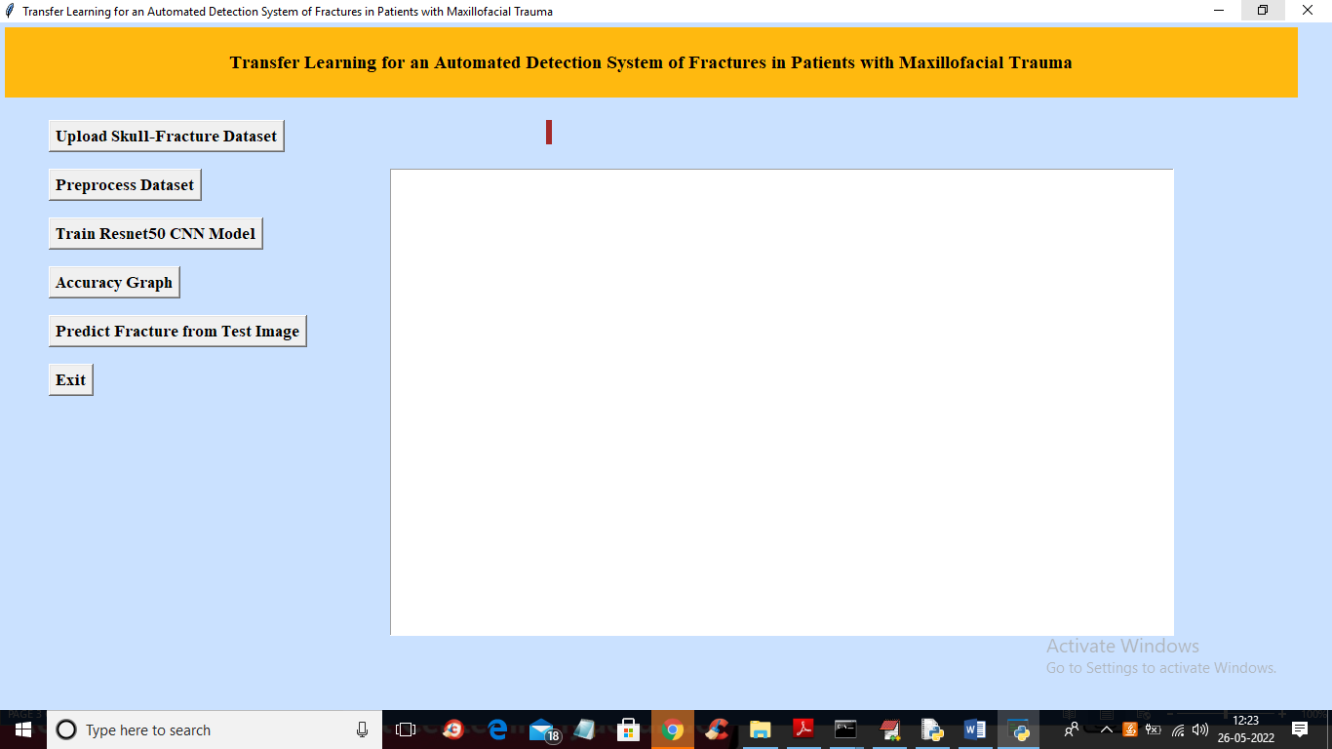

Figure 5.1: GUI/Main Interface of the Automated Maxillofacial Fracture Detection System Using Deep Learning

Loaded Sample Image:
In below screen selecting and uploading ‘Dataset’ folder and then click on ‘Select Folder’ button to load dataset and get below output
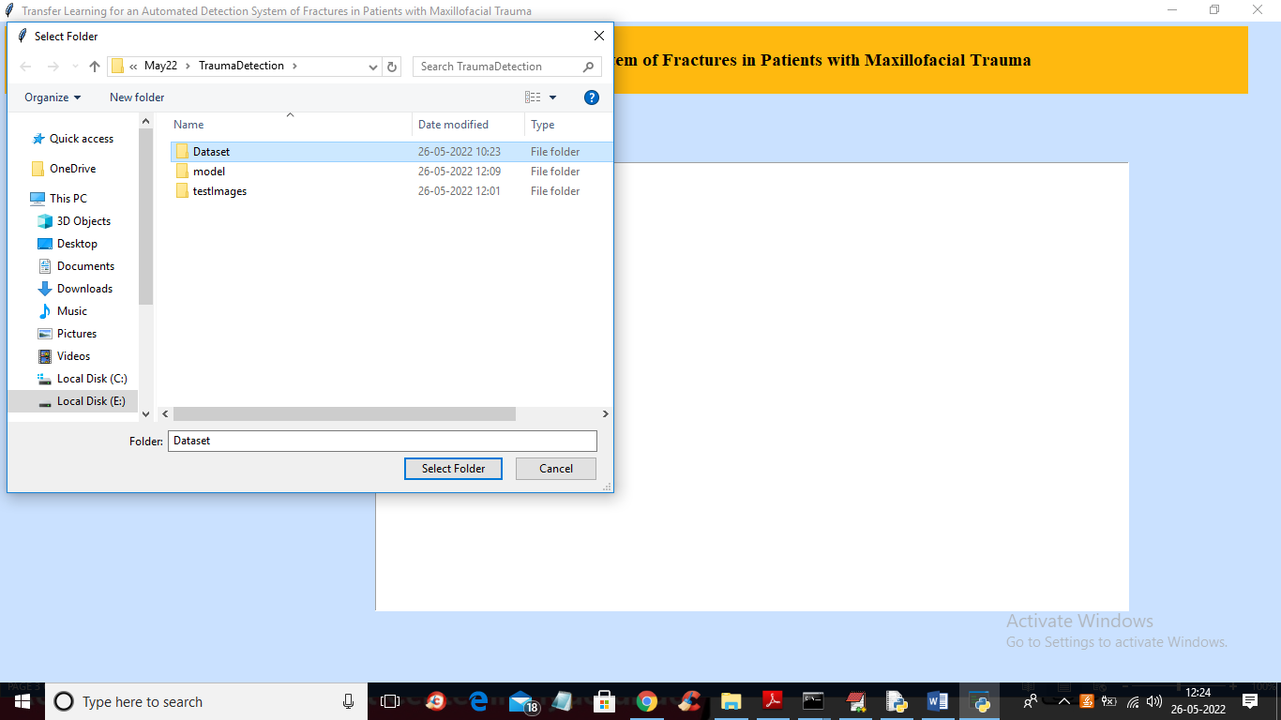
Figure 5.2: Dataset Upload Interface of the Transfer Learning-Based Maxillofacial Fracture Detection System

Dataset:
In below screen dataset loaded and now click on ‘Preprocess Dataset’ button to read all images and normalize them

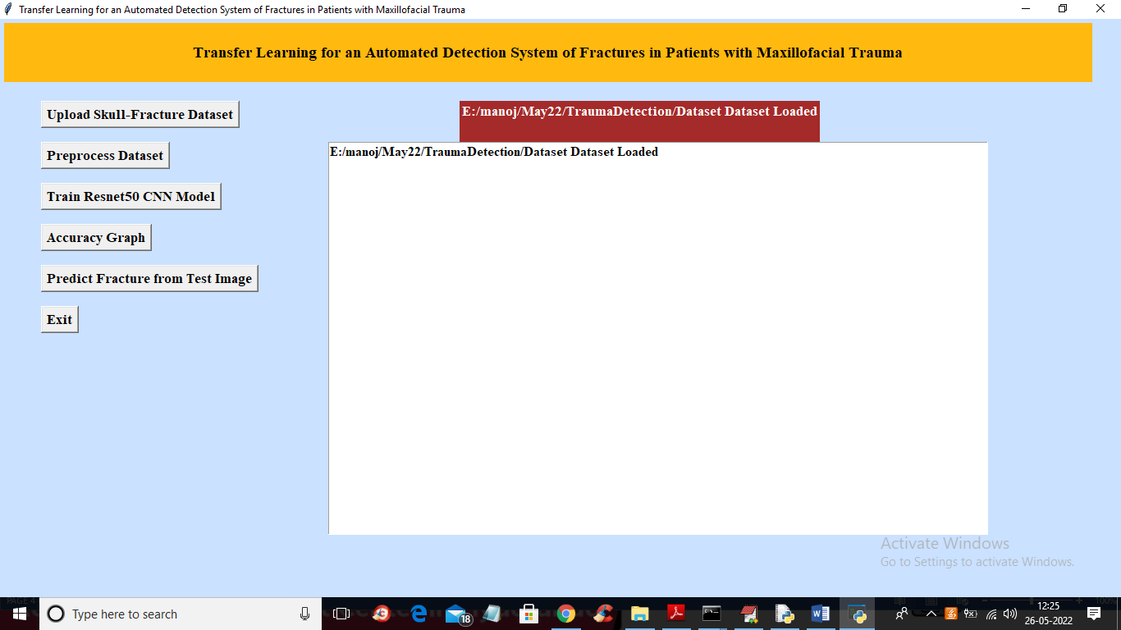
Figure 5.3: Loaded Dataset of the Transfer Learning-Based Maxillofacial Fracture Detection System

Sample Processed Image:
In below screen showing one processed image to check all images are loaded properly and now close above image to get below output

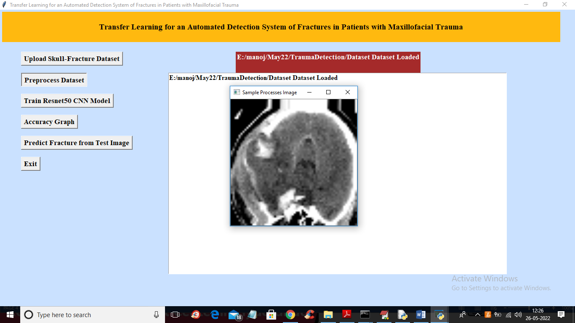
Figure 5.4: Preprocessed CT Scan Image in the Transfer Learning-Based Maxillofacial Fracture Detection System

Display of No. Of Items and Labels Present:
In below screen dataset contains total 305 images and application using 244 images for training and 61 images for testing and now click on ‘Train Resnet50 CNN Model’ button to train Resnet50 transfer learning with CNN and get below output

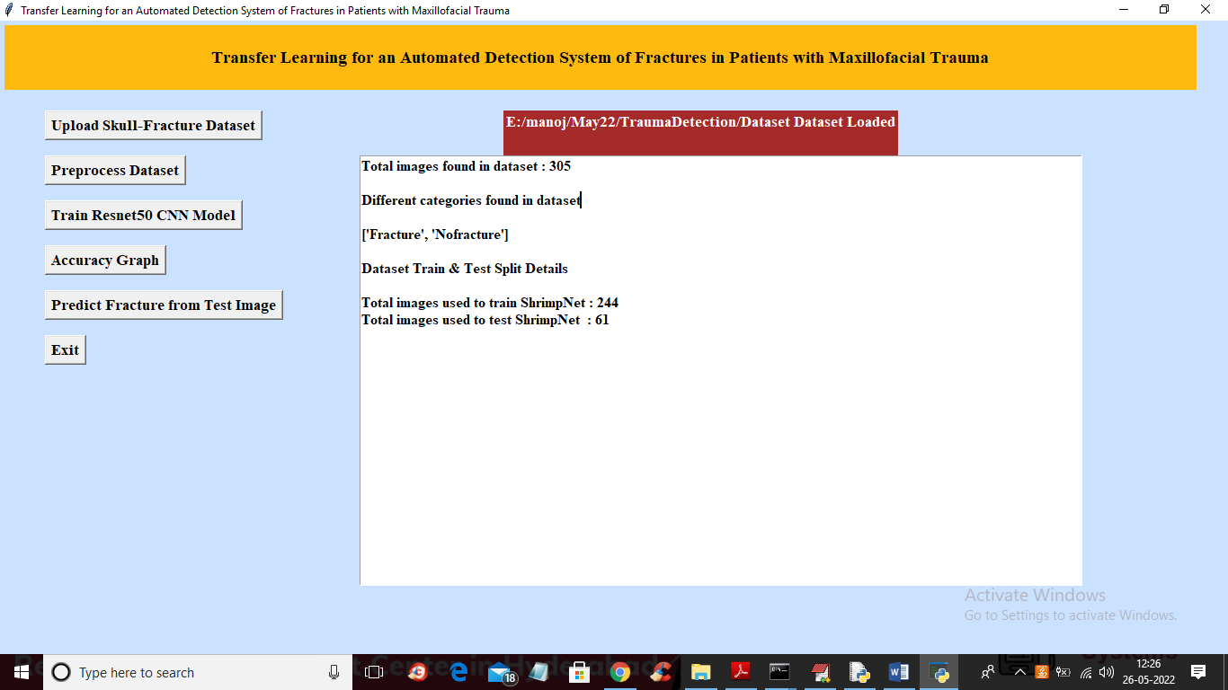
Figure 5.5: Dataset Summary and Train-Test Split in the Fracture Detection System

Confusion Matrix of ResNet50 Transfer Learning Model
In below confusion matrix graph x-axis represents PREDICTED CLASSES and y-axis represents TRUE classes and in above screen we can see CNN predicted 36 classes correctly as FRACTURED and only 2 classes are incorrectly predicted and all 23 non-fractured images are correctly predicted. Now close above graph to get below output

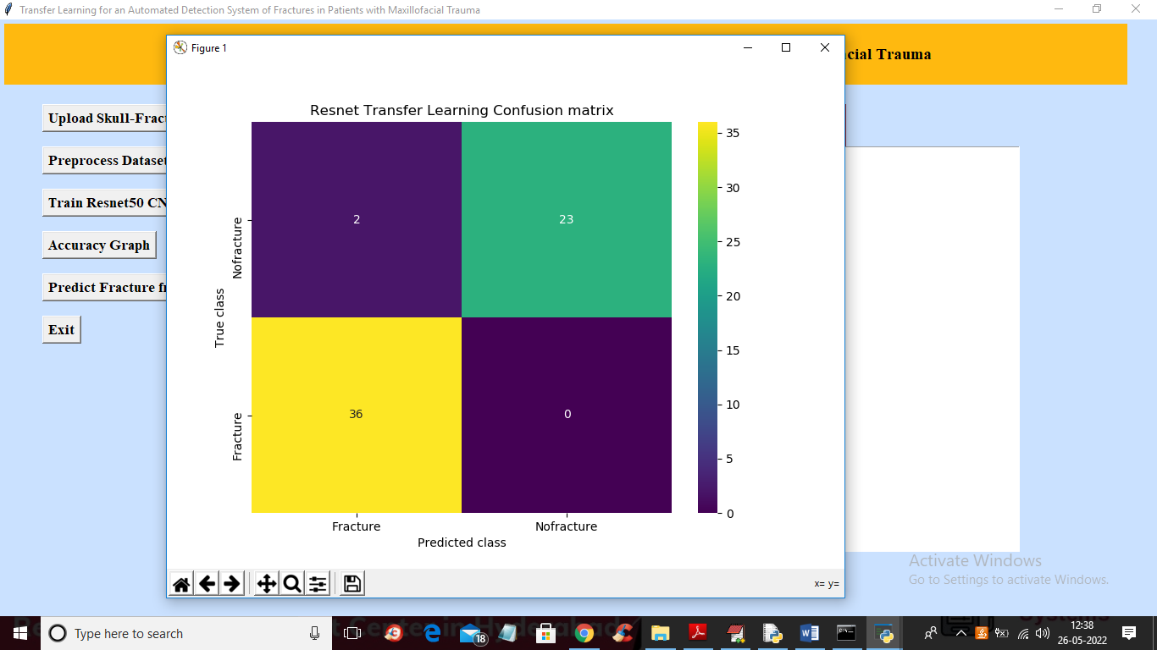

Figure 5.6: Performance Evaluation using Confusion Matrix of the Proposed Fracture Detection Model

Model Performance Results:
In the below screen, the performance of the ResNet50 transfer learning model is displayed. The model achieved an accuracy of approximately 96%, along with high precision, recall, and F1-score values. These results indicate that the model performs effectively in classifying CT scan images as fracture or non-fracture. After viewing the results, the user can click on the “Accuracy Graph” button to visualize the model performance graphically.

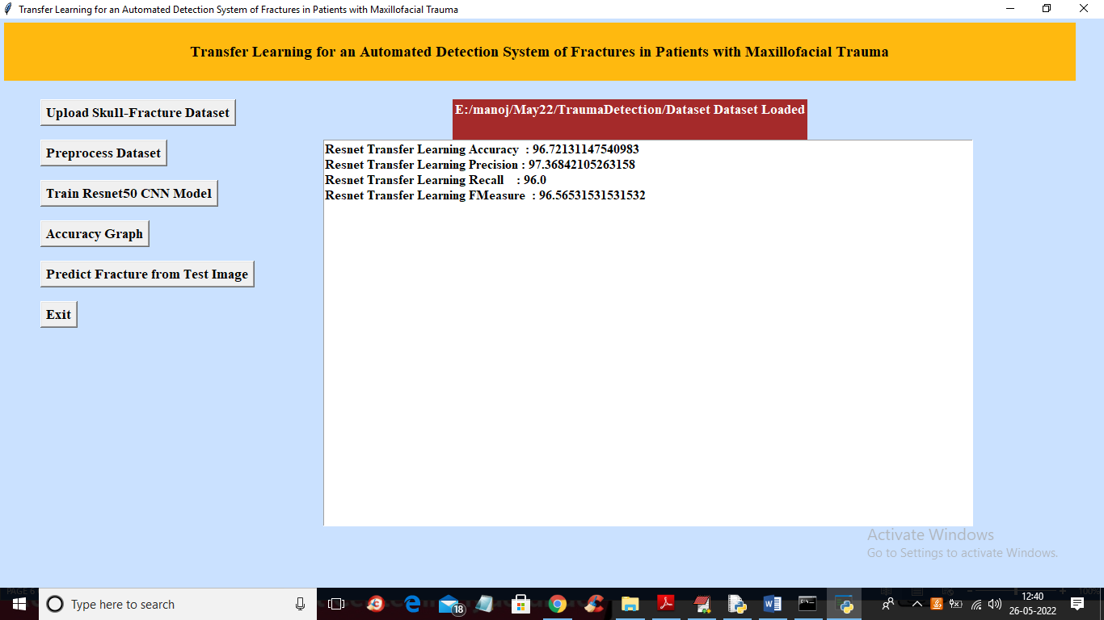

Figure 5.7: Performance Metrics of ResNet50 Transfer Learning Model

Accuracy and Loss Analysis
In the below graph, the x-axis represents the training epochs and the y-axis represents the accuracy and loss values. The green line indicates the model accuracy, while the blue line represents the loss. It can be observed that as the number of epochs increases, the accuracy of the model improves, and the loss decreases. This indicates that the model is learning effectively and performing well. After analyzing the graph, the user can proceed by clicking on the “Predict Fracture from Test Image” button to upload a test image and obtain the prediction result.

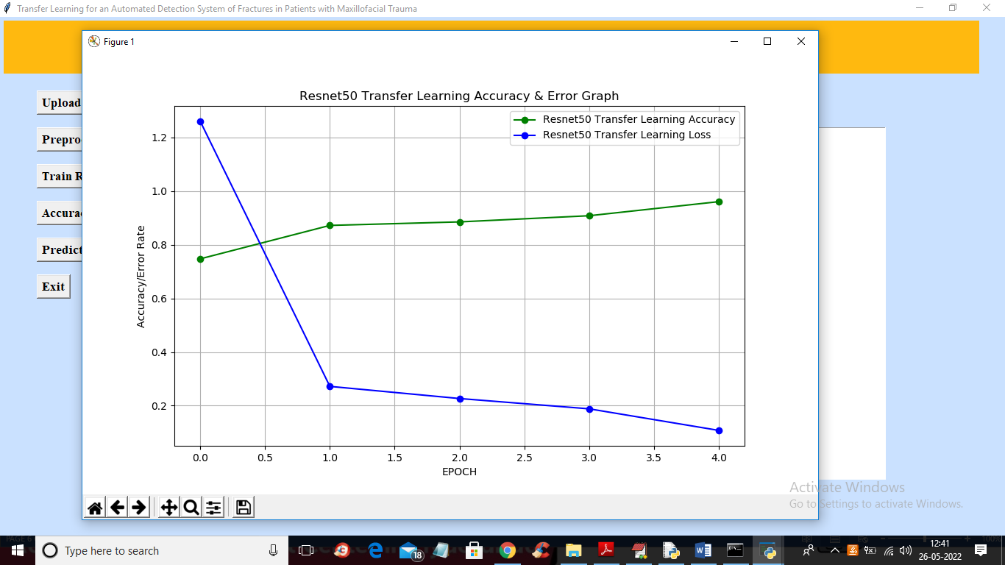

Figure 5.8: Accuracy and Loss Graph of ResNet50 Transfer Learning Model

Fracture Prediction from Test Image:
In the below screen, a test CT scan image (2.png) is selected and uploaded into the system. After clicking the “Open” button, the model processes the image and displays the prediction result. The output is shown in blue text, indicating that the given image is classified as “No Fracture.” This demonstrates the model’s ability to accurately analyze and classify new input images. The user can further test the system by uploading additional images for prediction.

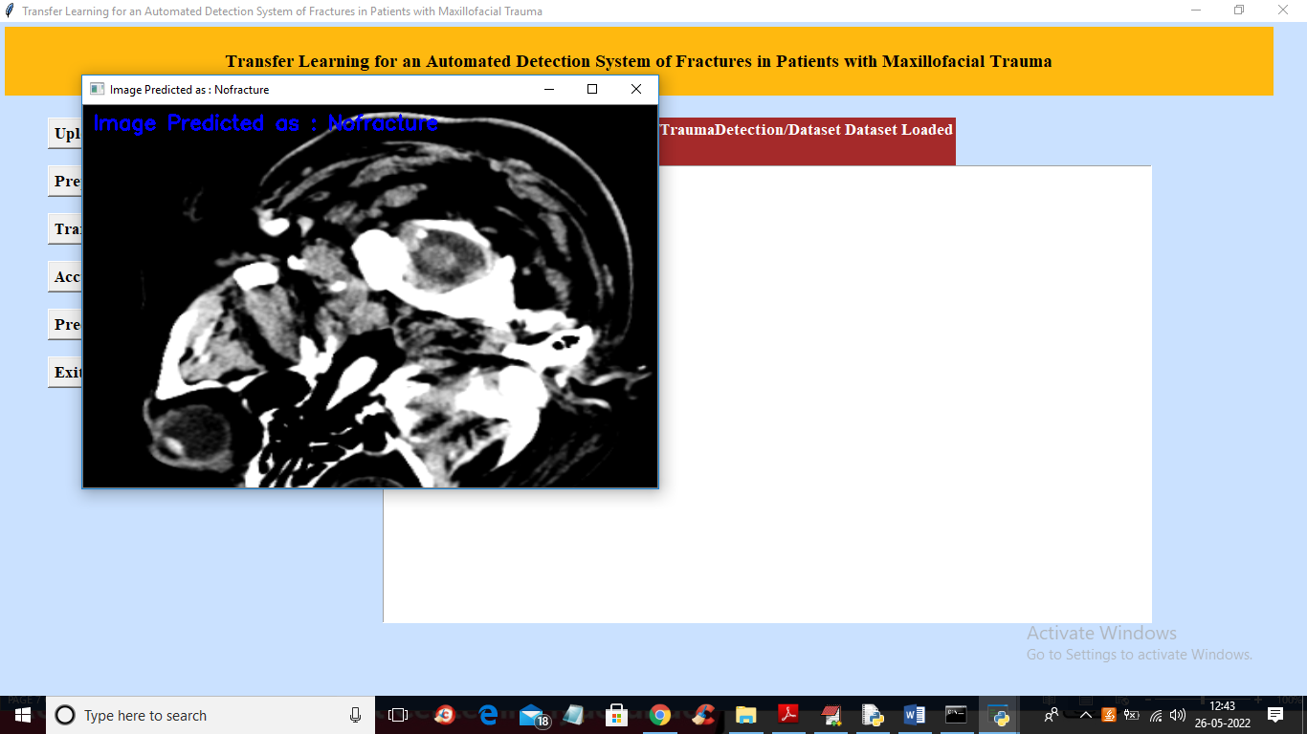

Figure 5.9: Prediction Output for Test CT Scan Image (No Fracture)

Fracture Detection from Test Image
In the below screen, a test CT scan image (4.png) is selected and uploaded into the system. After clicking the “Open” button, the model processes the image and displays the prediction result. The output is shown in blue text, indicating that the given image is classified as “Fracture.” This demonstrates the system’s ability to accurately detect fracture cases. Similarly, users can upload different images to test the performance of the model.

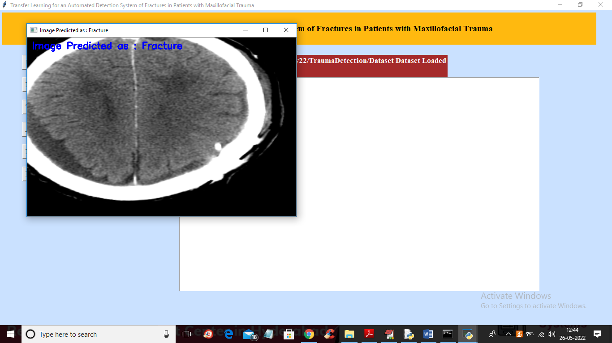
Figure 5.10: Prediction Output for Test CT Scan Image (Fracture)

VALIDATION

6. VALIDATION

The validation of this project primarily relies on extensive testing and well-defined test cases to ensure the accuracy and effectiveness of the fracture detection system. The testing process involves multiple stages, including dataset validation, model performance evaluation, and real-world testing. By implementing a structured validation approach, the system ensures consistent performance in accurately detecting fractures while minimizing false positives and false negatives.

INTRODUCTION

First, the dataset is divided into training and testing sets using an 80-20 split. The training set is used to train the ResNet50-based deep learning model, enabling it to learn important features from CT scan images. The testing set is used to evaluate the model’s performance on unseen data, ensuring that it generalizes well and does not overfit.
During training, the model learns to extract meaningful patterns related to fractures using transfer learning. The performance of the system is evaluated using key metrics such as accuracy, precision, recall, and F1-score. These metrics provide a comprehensive understanding of the model’s effectiveness in correctly identifying fracture and non-fracture cases.
A confusion matrix is also used to analyse the classification results in detail. It helps in identifying true positives, true negatives, false positives, and false negatives, allowing better evaluation of the model’s strengths and weaknesses. This analysis ensures that the model performs reliably in different scenarios.
Furthermore, the model’s learning behaviour is observed using accuracy and loss graphs over multiple training epochs. An increase in accuracy and a decrease in loss indicate that the model is learning effectively.
Finally, the system is tested using new CT scan images to simulate real-world conditions. The results demonstrate that the model can accurately predict fracture and non-fracture cases, making it a reliable tool to assist radiologists in faster and more efficient diagnosis. Continuous testing and evaluation help in improving the overall performance and robustness of the system.

TEST CASES

TABLE 6.2.1: UPLOADING DATASET

Test Case ID | Test Case Name | Purpose | Test Case | Output
1 | User uploads Dataset. | Use it for content prediction | The user uploads the Dataset, on which the content is detected. | Dataset successfully loaded.

TABLE 6.2.2: CLASSIFICATION

Test Case ID | Test Case Name | Purpose | Input | Output
1 | Classification test 1 | To check if the model correctly detects non-fracture cases | CT scan image without fracture | No Fracture
2 | Classification test 2 | To check if the model correctly detects fracture cases | CT scan image with fracture | Fracture

- CONCLUSION & FUTURE ASPECTS

7. CONCLUSION & FUTURE ASPECTS
In conclusion, the project has successfully achieved its objectives, showcasing significant progress and outcomes. The implementation and execution phases were meticulously planned and executed, leading to substantial improvements and insights. Looking ahead, the future aspects of the project hold immense potential. Future developments will focus on expanding the scope, integrating new technologies, and enhancing sustainability. These advancements will not only strengthen the existing framework but also open new avenues for growth and innovation, ensuring the project remains relevant and impactful in the long term. This strategic approach will drive continuous improvement and success.

PROJECT CONCLUSION

This project presents a reliable and efficient deep learning-based system for the automated detection of maxillofacial fractures using CT scan images. The proposed approach leverages transfer learning with the ResNet50 model, enabling effective feature extraction and classification even with a limited dataset. By utilizing pre-trained knowledge, the system reduces training time while maintaining high accuracy in fracture detection.
The model demonstrates strong performance in classifying CT scan images into fracture and non-fracture categories, supported by evaluation metrics such as accuracy, precision, recall, and F1-score. The confusion matrix analysis further confirms the model’s capability to minimize misclassification and improve diagnostic reliability.
Compared to traditional manual diagnosis, the proposed system significantly reduces the time required for analysis and minimizes human error. It serves as a supportive tool for radiologists, assisting in faster and more accurate decision-making. Although the system does not replace medical professionals, it enhances the efficiency of the diagnostic process.
Overall, this project highlights the potential of deep learning and transfer learning techniques in medical imaging applications. The developed system provides a scalable and practical solution for automated fracture detection, contributing to advancements in healthcare technology.

FUTURE ASPECTS
While the proposed system achieves promising results, there are several opportunities for further enhancement and development to improve its performance and real-world applicability.
- Expanding the dataset with more diverse and high-quality CT scan images to improve generalization and accuracy
- Implementing advanced models such as 3D CNNs to analyze volumetric CT scan data more effectively
- Integrating the system with hospital information systems for real-time clinical usage
- Developing a web or mobile-based application for easier accessibility and deployment
- Enhancing model explainability using visualization techniques like Grad-CAM for better medical interpretation
- Incorporating continuous learning mechanisms to adapt to new data and improve performance over time
- Improving computational efficiency for faster processing and real-time predictions
- Extending the system to detect other types of fractures or medical abnormalities

BIBLIOGRAPHY

BIBLIOGRAPHY

REFERENCES

[1] P. H. S. Kalmet, S. Sanduleanu, S. Primakov, G. Wu, A. Jochems, T. Refaee, A. Ibrahim, L. V. Hulst, P. Lambin, and M. Poeze, “Deep learning in fracture detection: A narrative review,” Acta Orthopaedica, vol. 91, pp. 215–220, 2020.
[2] V. Gulshan, L. Peng, M. Coram, M. C. Stumpe, D. Wu, A. Narayanaswamy, et al., “Development and validation of a deep learning algorithm for detection of diabetic retinopathy in retinal fundus photographs,” JAMA, vol. 316, no. 22, pp. 2402–2410, 2016.
[3] J. G. Lee, S. Jun, Y. W. Cho, H. Lee, G. B. Kim, J. B. Seo, and N. Kim, “Deep learning in medical imaging: General overview,” Korean Journal of Radiology, vol. 18, pp. 570–584, 2017.
[4] A. Tang, R. Tam, A. Cadrin-Chênevert, W. Guest, J. Chong, J. Barfett, et al., “Canadian Association of Radiologists white paper on artificial intelligence in radiology,” Canadian Association of Radiologists Journal, vol. 69, pp. 120–135, 2018.
[5] H. D. Kim and T. MacKinnon, “Artificial intelligence in fracture detection: Transfer learning from deep convolutional neural networks,” Clinical Radiology, vol. 73, pp. 439–445, 2018.
[6] S. W. Chung, S. S. Han, J. W. Lee, K. S. Oh, N. R. Kim, J. P. Yoon, et al., “Automated detection and classification of the proximal humerus fracture by using deep learning algorithm,” Acta Orthopaedica, vol. 89, pp. 468–473, 2018.
[7] N. Tomita, Y. Y. Cheung, and S. Hassanpour, “Deep neural networks for automatic detection of osteoporotic vertebral fractures on CT scans,” Computer Biology and Medicine, vol. 98, pp. 8–15, 2018.
[8] G. Litjens, T. Kooi, B. E. Bejnordi, A. A. A. Setio, F. Ciompi, M. Ghafoorian, et al., “A survey on deep learning in medical image analysis,” Medical Image Analysis, vol. 42, pp. 60–88, 2017.
[9] A. Esteva, B. Kuprel, R. A. Novoa, J. Ko, S. M. Swetter, H. M. Blau, and S. Thrun, “Dermatologist-level classification of skin cancer with deep neural networks,” Nature, vol. 542, pp. 115–118, 2017.
[10] C. Szegedy, W. Liu, Y. Jia, P. Sermanet, S. Reed, D. Anguelov, et al., “Going deeper with convolutions,” in Proc. IEEE CVPR, 2015, pp. 1–9.
[11] K. He, X. Zhang, S. Ren, and J. Sun, “Deep residual learning for image recognition,” in Proc. IEEE CVPR, 2016, pp. 770–778.
[12] G. Huang, Z. Liu, L. Van Der Maaten, and K. Q. Weinberger, “Densely connected convolutional networks,” in Proc. IEEE CVPR, 2017, pp. 4700–4708.
[13] O. Russakovsky, J. Deng, H. Su, J. Krause, S. Satheesh, M. Ma, et al., “ImageNet large scale visual recognition challenge,” International Journal of Computer Vision, vol. 115, pp. 211–252, 2015.
[14] M. S. Heo, J. E. Kim, J. J. Hwang, S. S. Han, J. S. Kim, W. J. Yi, and I. W. Park, “Artificial intelligence in oral and maxillofacial radiology: What is currently possible?” Dentomaxillofacial Radiology, vol. 50, 2021.
[15] K. Hung, C. Montalvao, R. Tanaka, T. Kawai, and M. M. Bornstein, “The use and performance of artificial intelligence applications in dental and maxillofacial radiology: A systematic review,” Dentomaxillofacial Radiology, vol. 49, 2020.
[16] R. Nagi, K. Aravinda, N. Rakesh, R. Gupta, A. Pal, and A. K. Mann, “Clinical applications and performance of intelligent systems in dental and maxillofacial radiology: A review,” Imaging Science in Dentistry, vol. 50, pp. 81–92, 2020.
[17] S. Raschka, “Model evaluation, model selection, and algorithm selection in machine learning,” arXiv preprint arXiv:1811.12808, 2018.
[18] J. Bergstra and Y. Bengio, “Random search for hyper-parameter optimization,” Journal of Machine Learning Research, vol. 13, pp. 281–305, 2012.
[19] J. Howard and S. Gugger, “FastAI: A layered API for deep learning,” Information, vol. 11, 2020.
[20] J. A. Hanley and B. J. McNeil, “The meaning and use of the area under a receiver operating characteristic (ROC) curve,” Radiology, vol. 143, pp. 29–36, 1982.
[21] A. Nicholls, “Confidence limits, error bars and method comparison in molecular modeling,” Journal of Computer-Aided Molecular Design, vol. 28, pp. 887–918, 2014.
[22] M. Murero, “Building artificial intelligence for digital health: A socio-tech-med approach,” Ethnography and Qualitative Research, vol. 13, pp. 374–388, 2020.
[23] A. Comelli, C. Coronnello, N. Dahiya, V. Benfante, S. Palmucci, A. Basile, et al., “Lung segmentation on high-resolution CT images using deep learning,” Journal of Imaging, vol. 6, 2020.

